Women's Clothing
Trends and Analysis in the Fashion Industry
Distribution of Ratings and Recommendations Using Advanced Statistical Analysis, Gaussian Mixture Modeling and Anomaly Detection

Executive Summary
This report analyzes the distribution and relationship of customer ratings and product recommendations in a women's clothing review dataset. The analysis combines descriptive statistics, non-parametric association tests, Gaussian mixture modeling (GMM), probabilistic segmentation and multi-signal anomaly detection. The dataset contains 23,486 reviews and 11 original variables. Core analytical fields - Rating, Recommended IND, Age and Positive Feedback Count - contain no missing values.
KEY FINDING Customer sentiment is strongly positive: 77.53% of reviews have ratings 4-5 and 82.24% recommend the product. Rating and recommendation show a very strong association (Cramer's V = 0.8437).

Key Results at a Glance
Metric | Result | Interpretation
Total reviews | 23,486 | Complete rating and recommendation fields
Average rating | 4.196 / 5 | Median and mode are both 5
Recommendation rate | 82.24% | 19,314 recommended reviews
Association strength | V = 0.8437 | Very strong rating-recommendation association
GMM solution | 7 clusters | full covariance; converged
Final anomalies | 467 | 1.99% of records

Contents
Section | Topic
1 | Introduction and Objectives
2 | Dataset Overview and Preparation
3 | Methodology
4 | Ratings and Recommendation Findings
5 | Gaussian Mixture Modeling
6 | Anomaly Detection
7 | Deeper Trend Insights
8 | Recommendations
9 | Limitations and Conclusion
Appendix | Technical Summary

1. Introduction and Objectives

1.1 Background
Customer ratings summarize perceived product quality, while recommendation indicators capture purchase advocacy. In fashion retail, their relationship can be influenced by fit, sizing, fabric, occasion and expectations, making segmentation and anomaly detection especially valuable.

1.2 Problem Statement
Simple averages can hide minority patterns and unusual rating-recommendation combinations. This project tests the association, discovers latent GMM segments, detects anomalies and compares department and age-group trends.

1.3 Objectives
ID | Objective
O1 | Describe the distribution of ratings and recommendations.
O2 | Measure the strength and significance of their relationship.
O3 | Engineer and scale features for probabilistic segmentation.
O4 | Select a GMM using AIC, BIC and silhouette diagnostics.
O5 | Profile interpretable customer-review segments.
O6 | Detect density, confidence, contradiction and numerical anomalies.
O7 | Extract department, class and age-group business insights.

1.4 Scope
The unit of analysis is one customer-review record. Findings describe patterns in the uploaded dataset and do not establish causal effects. The GMM is used for exploratory segmentation rather than prediction of future purchases.

2. Dataset Overview and Preparation

2.1 Dataset Structure
Property | Observed value
Rows | 23,486
Original columns | 11
Duplicate rows | 0
Age range | 18-99 years
Rating range | 1-5
Recommendation values | 0 = no; 1 = yes
Positive feedback range | 0-122
Core-field missing values | 0

2.2 Missingness and Data Quality
Field | Missing | Treatment
Title | 3,810 | Not used in the numerical GMM
Review Text | 845 | Converted to Review Length = 0 when absent
Division Name | 14 | Labeled Unknown
Department Name | 14 | Labeled Unknown
Class Name | 14 | Labeled Unknown

The sequential 'no' field was excluded because it functions as a row identifier rather than an analytical feature. Missing category labels were preserved as Unknown. Reviews with missing text were retained because their ratings and recommendations remain valid.

2.3 Feature Engineering
Feature | Transformation | Final treatment
Age | Original numeric | StandardScaler
Rating | Original ordinal | StandardScaler
Recommended IND | Original binary | StandardScaler
Positive Feedback Count | log(1 + x) | StandardScaler
Review Length | Word count then log(1 + x) | StandardScaler

MODELING NOTE GMM assumes Gaussian continuous features. Rating is ordinal and recommendation is binary, so the resulting clusters are interpreted as exploratory behavioral segments, not a perfect generative representation.

3. Methodology

3.1 Descriptive and Association Analysis
Frequencies, percentages, mean, median and mode summarized the distributions. A row-normalized contingency table measured recommendation probability within each rating. Pearson's chi-square test evaluated independence, bias-corrected Cramer's V measured association strength, and Spearman's rank correlation measured the monotonic relationship.
Technique | Concept | Purpose
Chi-square | Sum[(Observed - Expected)^2 / Expected] | Tests independence
Cramer's V | sqrt(chi-square / adjusted sample-size term) | Measures effect size
Spearman rho | Rank-based correlation | Measures monotonic direction

3.2 Gaussian Mixture Modeling
Twenty-four candidate models were fitted: 2-7 components across full, tied, diagonal and spherical covariance structures. Each model used three initializations, a maximum of 500 iterations, k-means initialization and covariance regularization of 0.00001. BIC was the primary selection criterion; AIC and a 4,000-record silhouette sample were supporting diagnostics.
GMM assigns each record a probability for every component. The component with maximum probability becomes the displayed cluster, while the maximum probability is retained as cluster confidence. This probabilistic structure is useful for identifying boundary cases.

3.3 Anomaly Detection Framework
Signal | Rule | Interpretation
GMM density | Bottom 1% log-density | Statistically unlikely pattern
Low confidence | Maximum probability < 0.70 | Cluster-boundary case
Contradiction | Rating 4-5 with no, or rating 1-2 with yes | Behavioral inconsistency
Numerical extremes | IQR rule on age, feedback and review length | Unusual feature combination
Composite score | 50% rarity + 20% uncertainty + 20% contradiction + 10% extremes | Unified prioritization

4. Ratings and Recommendation Findings

4.1 Rating Distribution
Rating | Frequency | Percentage
1 | 842 | 3.59%
2 | 1,565 | 6.66%
3 | 2,871 | 12.22%
4 | 5,077 | 21.62%
5 | 13,131 | 55.91%

Figure 1. Distribution of customer ratings
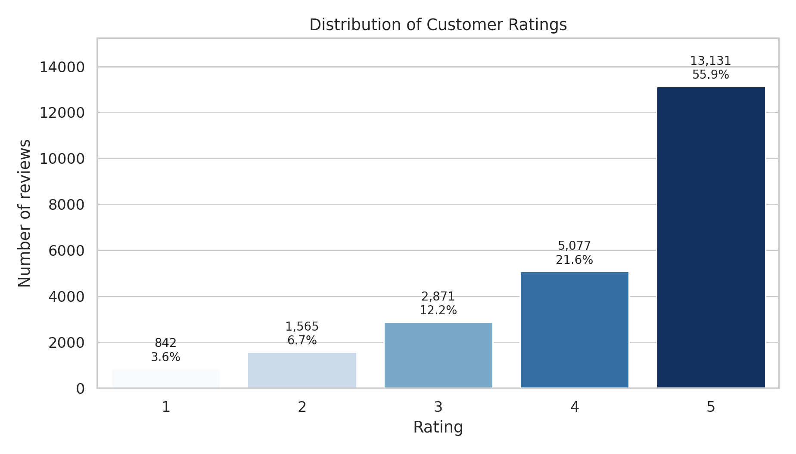
The distribution is concentrated at the positive end. Rating 5 accounts for 55.91% of reviews, while ratings 4-5 jointly account for 77.53%. The mean rating is 4.196; the median and mode are both 5. Low ratings remain analytically important because they represent dissatisfied customers rather than data errors.

4.2 Recommendation Distribution
Figure 2. Distribution of recommendation decisions
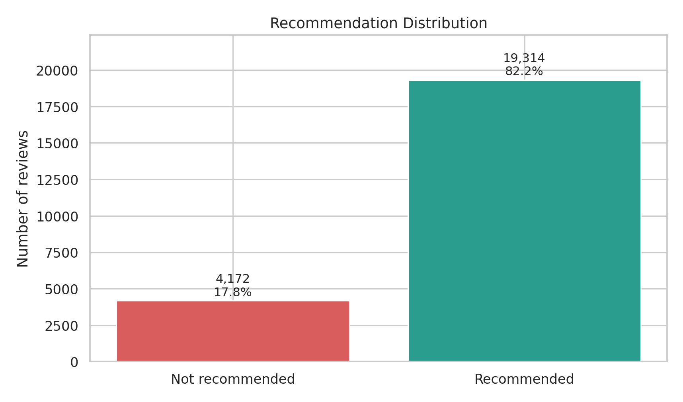
A total of 19,314 customers recommended the product and 4,172 did not. The recommendation rate is 82.24%, confirming substantial class imbalance toward positive advocacy.

4.3 Rating-Recommendation Relationship
Rating | Not recommended | Recommended
1 | 98.10% | 1.90%
2 | 93.99% | 6.01%
3 | 58.59% | 41.41%
4 | 3.31% | 96.69%
5 | 0.19% | 99.81%

Figure 3. Recommendation percentage within each rating
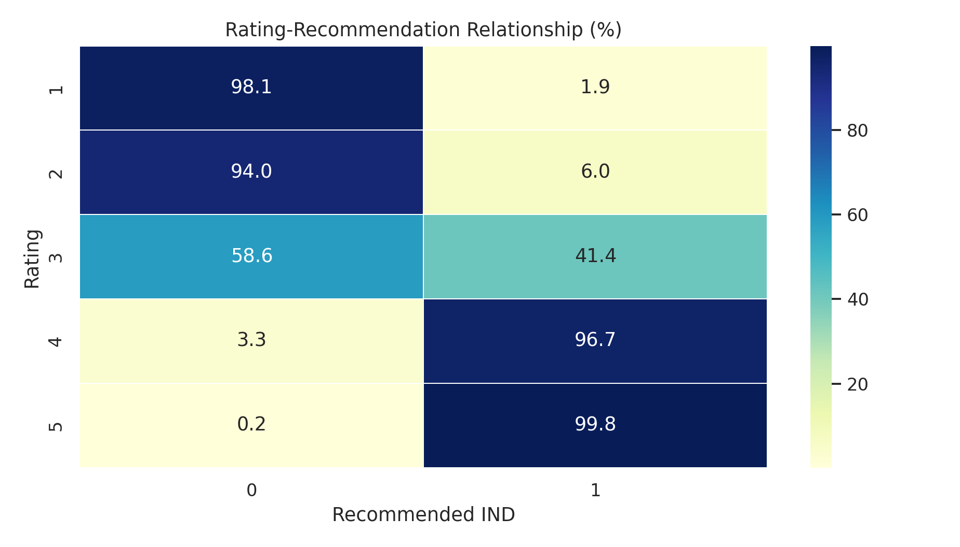

4.4 Statistical Evidence
Test | Statistic | Significance | Interpretation
Chi-square | 16722.503 | p < 0.001; df = 4 | Significant association
Cramer's V | 0.8437 | Effect size | Very strong
Spearman rho | 0.6935 | p < 0.001 | Strong positive

The null hypothesis of independence is rejected. Recommendation probability increases sharply with rating, and the effect is both statistically significant and practically strong. Rating 3 is the most mixed point: only 41.41% recommend, compared with 96.69% at rating 4.

4.5 Contradictory Responses
Pattern | Records | Dataset share
Rating 4-5 but not recommended | 193 | 0.822%
Rating 1-2 but recommended | 110 | 0.468%
Total direct contradictions | 303 | 1.290%

INTERPRETATION Contradictions are not automatically errors. A customer may like a product yet hesitate to recommend it because of fit, sizing or context; another may rate a specific issue poorly while still recommending the product overall.

5. Gaussian Mixture Modeling

5.1 Model Selection
Figure 4. BIC comparison across GMM configurations
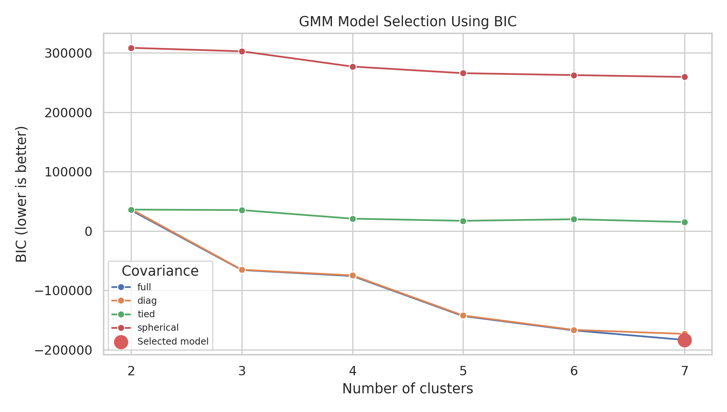
The lowest BIC was produced by a 7-component model with full covariance. The selected model converged in 19 iterations, with AIC = -184466.84 and BIC = -183289.48. A full covariance structure allows every segment to have its own feature covariance pattern.
Clusters | Covariance | AIC | BIC | Converged
7 | full | -184,466.8 | -183,289.5 | Yes
7 | diag | -173,729.6 | -173,116.8 | Yes
6 | full | -168,250.5 | -167,242.5 | Yes
6 | diag | -166,919.0 | -166,394.9 | Yes
5 | full | -143,992.2 | -143,153.6 | Yes
5 | diag | -142,621.8 | -142,186.3 | Yes

5.2 Segment Profiles
Cluster | Behavioral profile | Records | Share | Avg rating | Recommend
1 | Positive recommenders, zero feedback | 8,560 | 36.45% | 4.60 | 100.0%
2 | Dissatisfied non-recommenders, zero feedback | 1,632 | 6.95% | 2.32 | 0.0%
3 | Four-star engaged recommenders | 2,467 | 10.50% | 4.00 | 100.0%
4 | Mostly positive reviews with missing review text | 845 | 3.60% | 4.53 | 91.6%
5 | Five-star engaged recommenders | 6,791 | 28.92% | 5.00 | 100.0%
6 | Dissatisfied engaged non-recommenders | 2,469 | 10.51% | 2.29 | 0.0%
7 | Critical or mixed engaged recommenders | 722 | 3.07% | 2.90 | 100.0%

5.3 Segment Interpretation
Figure 5. Standardized model-feature profile of the seven GMM segments
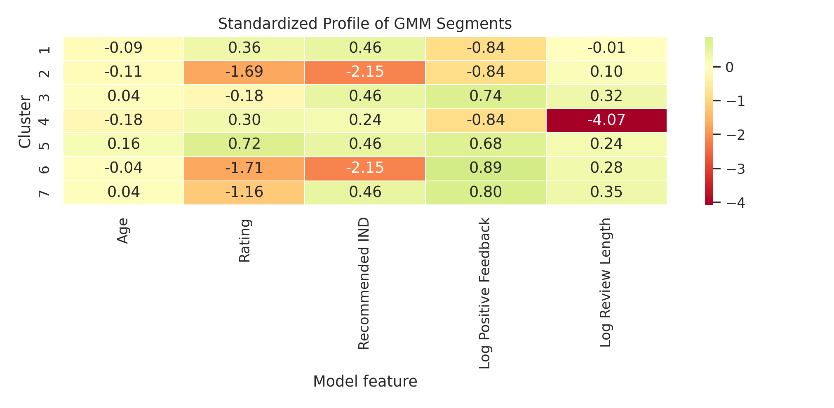
The solution separates sentiment, recommendation behavior and engagement. Clusters 1 and 5 are both highly positive, but Cluster 1 contains zero-feedback reviews while Cluster 5 contains highly engaged five-star reviews. Clusters 2 and 6 similarly separate dissatisfied non-recommenders by engagement. Cluster 4 isolates records with absent review text, showing that missing text forms a distinct data-behavior pattern. Cluster 7 captures critical or mixed ratings that still recommend the product.
SEGMENTATION INSIGHT The model does more than split positive and negative sentiment: it distinguishes engagement level, missing-review behavior and rating-recommendation consistency.

6. Anomaly Detection

6.1 Detection Results
Signal | Records | Meaning
Bottom 1% GMM density | 235 | Rare multivariate patterns
Cluster confidence below 0.70 | 4,084 | Boundary cases; not all are final anomalies
Direct contradictions | 303 | Unusual sentiment-advocacy combinations
Final combined anomaly flag | 467 | 1.99% of all records

Figure 6. Composite anomaly score and 99th-percentile threshold
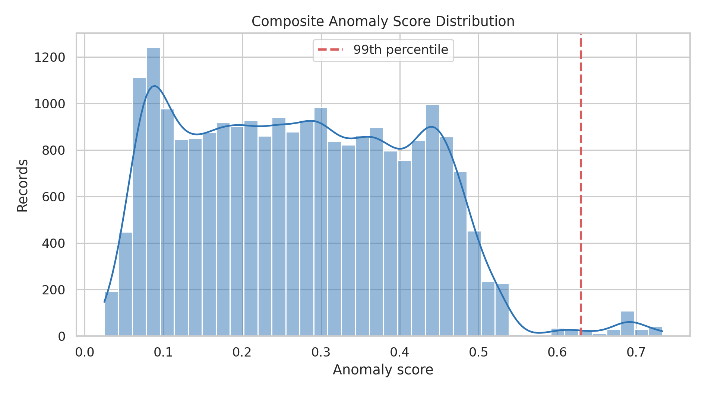
The final framework flagged 467 records (1.99%). The count exceeds 1% because the final rule also includes direct contradictions, density anomalies and records with multiple numerical extremes. Low-confidence observations are reported separately because uncertainty alone does not necessarily make a record anomalous.

6.2 Practical Use
Anomalies should be reviewed rather than automatically deleted. They can reveal niche customers, unusual sizing experiences, highly influential reviews, ambiguous recommendation decisions or possible data-quality issues. For operational use, the highest-scoring records should be paired with review-text inspection.

7. Deeper Trend Insights

7.1 Department Trends
Figure 7. Average rating and recommendation rate by department
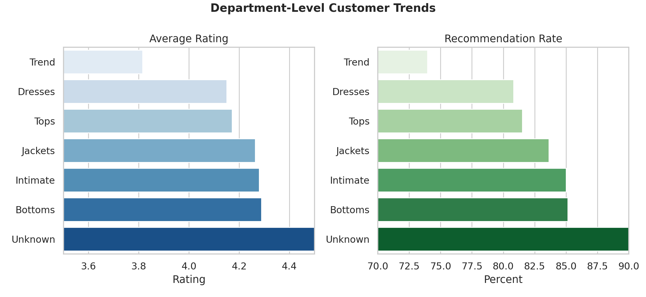
Department | Reviews | Avg rating | Recommend | Anomaly
Bottoms | 3,799 | 4.289 | 85.13% | 1.58%
Intimate | 1,735 | 4.280 | 85.01% | 1.67%
Jackets | 1,032 | 4.265 | 83.62% | 2.13%
Tops | 10,468 | 4.172 | 81.52% | 1.88%
Dresses | 6,319 | 4.151 | 80.82% | 2.47%
Trend | 119 | 3.815 | 73.95% | 2.52%

Among named departments, Bottoms has the highest average rating (4.289) and the highest recommendation rate (85.13%). Trend has the lowest average rating (3.815) and the highest anomaly rate among named departments (2.52%). The Trend result is based on only 119 reviews and therefore requires cautious interpretation.

7.2 Department Statistical Tests
Test | Statistic | Significance | Conclusion
Kruskal-Wallis ratings | H = 88.331 | p < 0.001 | Distributions differ
Department x recommendation | chi-square = 53.293 | p < 0.001 | Association exists
Cramer's V | V = 0.0449 | Effect size | Very weak practical association

Department differences are statistically significant, but the recommendation effect size is very small (V = 0.0449). With a large sample, small differences can produce low p-values; practical interpretation should therefore emphasize effect size and absolute rate differences.

7.3 Age-Group Trends
Age group | Reviews | Avg rating | Recommend | Anomaly
18-29 | 2,931 | 4.202 | 81.75% | 2.01%
30-39 | 7,702 | 4.170 | 81.36% | 1.57%
40-49 | 6,127 | 4.158 | 81.25% | 1.68%
50-59 | 3,948 | 4.236 | 83.76% | 2.18%
60-69 | 2,305 | 4.295 | 85.60% | 2.08%
70+ | 473 | 4.254 | 83.30% | 10.57%

Ratings and recommendation rates are broadly positive across age groups. The 60-69 group has the highest average rating (4.295) and recommendation rate (85.60%). The 70+ group has a much higher anomaly rate (10.57%), but it contains only 473 records; age extremes are also part of the anomaly framework, which contributes to this result.

7.4 Engagement Relationships
Variables | Spearman rho | Significance | Interpretation
Positive Feedback Count vs Rating | -0.0683 | p < 0.001 | Very weak negative
Positive Feedback Count vs Recommended IND | -0.0809 | p < 0.001 | Very weak negative
Review Length vs Rating | -0.0923 | p < 0.001 | Very weak negative
Review Length vs Recommended IND | -0.0423 | p < 0.001 | Very weak negative

Positive-feedback count and review length have statistically significant but very weak negative relationships with rating and recommendation. Detailed or widely endorsed reviews are therefore not necessarily more positive; they may instead reflect complex or critical experiences that other customers find useful.

8. Business Recommendations
Priority | Recommended action
Protect strong advocacy | Maintain quality and fit consistency in high-volume positive segments, especially five-star engaged recommenders.
Investigate rating 3 | Treat three-star reviews as the key conversion zone because recommendation is only 41.41% and customer sentiment is mixed.
Review contradictions | Read the 303 contradictory reviews to identify sizing, fit or expectation issues hidden by the headline rating.
Prioritize dissatisfied engaged reviews | Clusters with low ratings and nonzero feedback may contain detailed, high-value product-improvement signals.
Use anomalies for quality monitoring | Route the highest anomaly scores to manual review; do not delete them automatically.
Compare departments with effect sizes | Use practical rate differences and sample size, not p-values alone, when prioritizing departments.
Improve missing-text capture | Investigate the 845 records without review text because they form a distinct GMM segment.

8.1 Suggested Monitoring Indicators
Indicator | Cadence | Purpose
Positive rating rate | Monthly | Detect deterioration in ratings 4-5
Recommendation rate | Monthly | Track customer advocacy
Rating-3 recommendation rate | Monthly | Monitor conversion of mixed customers
Contradiction rate | Monthly | Identify unusual product experiences
Anomaly rate | Monthly | Detect shifts in customer behavior or data quality
Department effect size | Quarterly | Separate practical differences from sample-size effects

9. Limitations and Conclusion

9.1 Limitations
Limitation | Implication
GMM feature assumptions | The model includes ordinal and binary variables, which are not perfectly Gaussian.
Model-selection boundary | Only 2-7 clusters and four covariance structures were considered.
Missing review text | 845 missing reviews form a distinct pattern and may reflect collection behavior.
Small groups | Trend and 70+ groups have smaller samples, so their rates are less stable.
Anomaly rules | Thresholds and weights are analytical choices, not universal definitions of error.
No causal inference | Associations do not prove why a customer rated or recommended a product.

9.2 Conclusion
The dataset is dominated by favorable customer experiences: 77.53% of reviews are rated 4-5, and 82.24% recommend the product. Rating and recommendation have a very strong relationship (Cramer's V = 0.8437), while the three-star group represents the main zone of uncertainty.
A 7-component full-covariance GMM provided the best BIC among the tested models. The segments distinguish positive and negative sentiment, engagement, missing-review behavior and recommendation consistency. The combined anomaly framework identified 467 records (1.99%) for deeper review.
The project demonstrates that advanced statistical analysis and probabilistic segmentation reveal insights that averages alone cannot provide. The most actionable opportunities are the mixed three-star group, dissatisfied engaged reviewers, contradictory responses and high-scoring anomalies.
FINAL OUTCOME The requested distribution analysis, advanced statistical testing, Gaussian mixture segmentation, anomaly detection and deeper trend analysis were completed successfully on the uploaded dataset.

Segments and anomalies should support aggregate product-quality analysis. Model outputs should always be reviewed alongside sample size, uncertainty and qualitative review content.

Appendix A. Technical Summary
Parameter | Value
Software approach | Python; pandas, NumPy, SciPy, scikit-learn, Matplotlib and Seaborn
GMM features | Age, Rating, Recommended IND, log positive feedback, log review length
Scaling | StandardScaler; approximately zero mean and unit variance
Candidate models | 24 configurations: 2-7 clusters x 4 covariance types
Primary model criterion | Minimum BIC
GMM regularization | reg_covar = 0.00001
GMM initialization | k-means; 3 initializations; random_state = 42
Silhouette sample | 4,000 observations
Density anomaly | Bottom 1% GMM log-density
Confidence threshold | Maximum membership probability below 0.70
Final anomaly rule | Composite top 1% OR density anomaly OR contradiction OR two numerical extremes

Appendix B. Reproducibility Notes
All percentages use the complete 23,486-record dataset unless otherwise stated. Category missing values were labeled Unknown; no core analytical records were removed. Random-state controls were fixed at 42 for GMM initialization, silhouette sampling and visualization sampling. Exact model results may vary if feature definitions, cluster range, covariance choices, thresholds or software versions change.

Data Source
Source: uploaded CSV file e9047136-5b25-4c8f-bb99-5b2f636c363d.csv. All statistics, figures and interpretations in this report were calculated from that file for the project 'Women's Clothing: Trends and Analysis in the Fashion Industry.'

